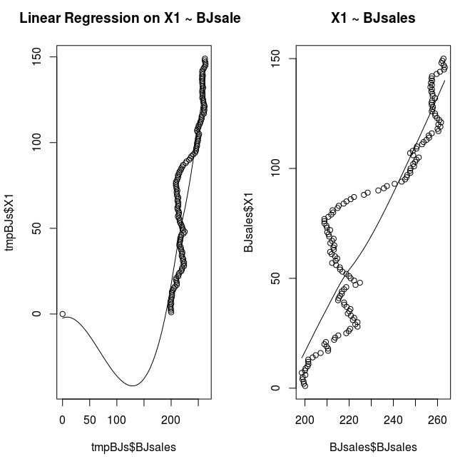
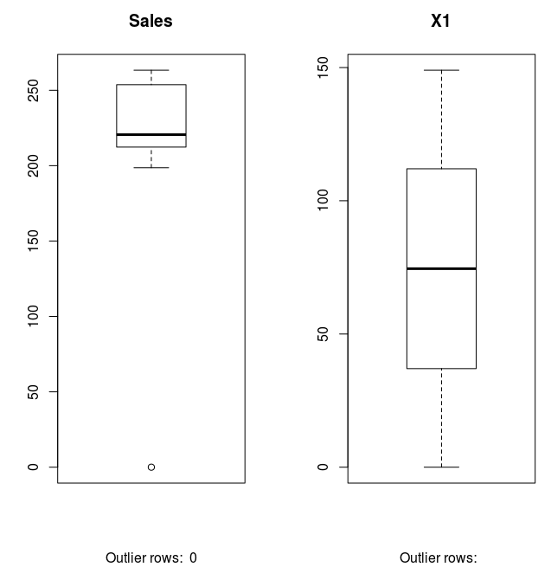
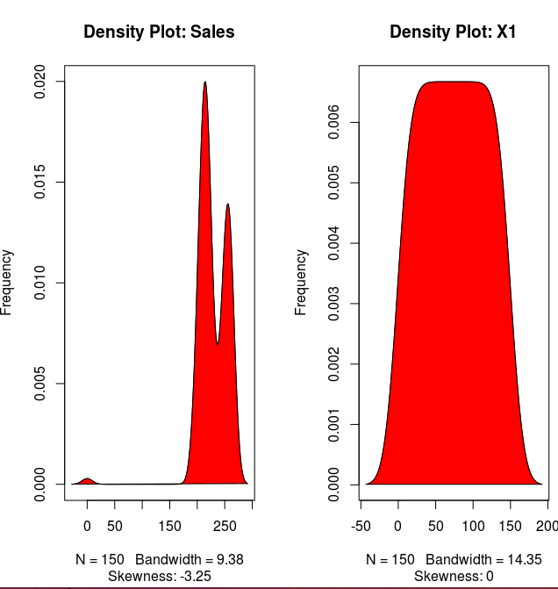
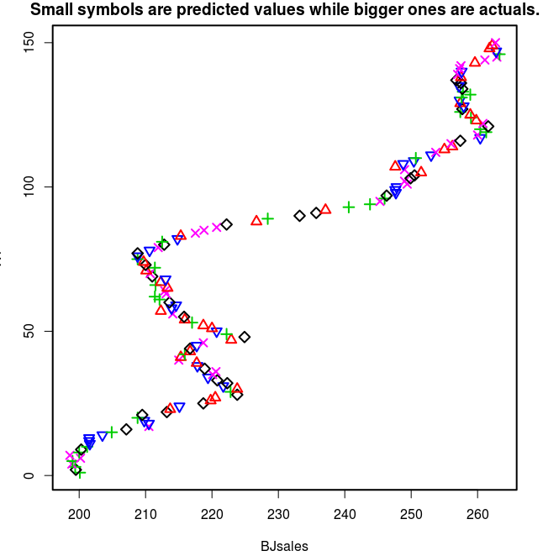
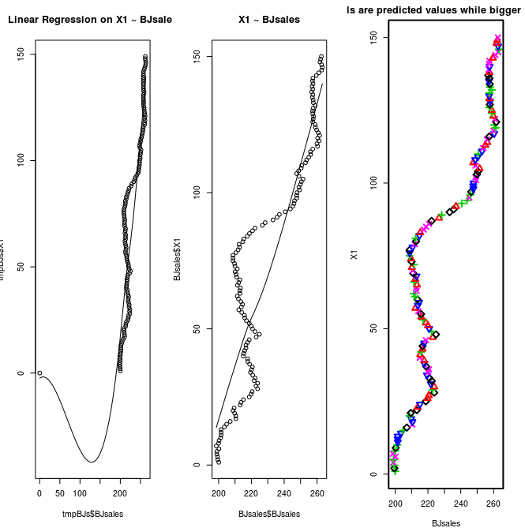
head(BJsales)
mpBJs<- BJsales[-nrow(BJsales),]

newRow <- data.frame(X1=0,time=150,BJsales=0)
tmpBJs <- rbind(tmpBJs,newRow)

par(mfrow=c(1, 2)) # divide graph area in 2 columns
scatter.smooth(x=tmpBJs$BJsales, y=tmpBJs$X1, main="Linear Regression on X1 ~ BJsales") # scatterplot
scatter.smooth(x=BJsales$BJsales, y=BJsales$X1, main="X1 ~ BJsales") # scatterplot

par(mfrow=c(1, 2)) # divide graph area in 2 columns
boxplot(tmpBJs$BJsales, main="Sales", sub=paste("Outlier rows: ", boxplot.stats(tmpBJs$BJsales)$out)) # box plot for 'Sales'
boxplot(tmpBJs$X1, main="X1", sub=paste("Outlier rows: ", boxplot.stats(tmpBJs$X1)$out)) # box plot for 'X1'

install.packages("e1071")
library(e1071)
par(mfrow=c(1, 2)) # divide graph area in 2 columns
plot(density(tmpBJs$BJsales), main="Density Plot: Sales", ylab="Frequency", sub=paste("Skewness:", round(e1071::skewness(tmpBJs$BJsales), 2))) # density plot for 'Sales'
polygon(density(tmpBJs$BJsales), col="red")
plot(density(tmpBJs$X1), main="Density Plot: X1", ylab="Frequency", sub=paste("Skewness:", round(e1071::skewness(tmpBJs$X1), 2))) # density plot for 'dist'
polygon(density(tmpBJs$X1), col="red")

cor(tmpBJs$BJsales, tmpBJs$X1) # calculate correlation between speed and distance
#> [1] 0.8068949

linearMod <- lm(X1 ~ BJsales, data=BJsales) # build linear regression model on full data
print(linearMod)
summary(linearMod) # model summary

modelSummary <- summary(linearMod) # capture model summary as an object
modelCoeffs <- modelSummary$coefficients # model coefficients
beta.estimate <- modelCoeffs["BJsales", "Estimate"] # get beta estimate for speed
std.error <- modelCoeffs["BJsales", "Std. Error"] # get std.error for speed
t_value <- beta.estimate/std.error # calc t statistic
p_value <- 2*pt(-abs(t_value), df=nrow(BJsales)-ncol(BJsales)) # calc p Value
f_statistic <- linearMod$fstatistic[1] # fstatistic
f <- summary(linearMod)$fstatistic # parameters for model p-value calc
model_p <- pf(f[1], f[2], f[3], lower=FALSE)

AIC(linearMod) # AIC => 419.1569
BIC(linearMod) # BIC => 424.8929
#---------------------------------------------------------------------------------------------
# Create Training and Test data -
trainingRowIndex <- sample(1:nrow(BJsales), 0.8*nrow(BJsales)) # row indices for training data
trainingData <- BJsales[trainingRowIndex, ] # model training data
testData <- BJsales[-trainingRowIndex, ] # test data

# Build the model on training data -
lmMod <- lm(X1 ~ BJsales, data=trainingData) # build the model
x1Pred <- predict(lmMod, testData) # predict distance
summary (lmMod) # model summary
AIC (lmMod)

actuals_preds <- data.frame(cbind(actuals=testData$X1, predicted=x1Pred)) # make actuals_predicteds dataframe.
correlation_accuracy <- cor(actuals_preds) # 82.7%
head(actuals_preds)

min_max_accuracy <- mean(apply(actuals_preds, 1, min) / apply(actuals_preds, 1, max))
# => 58.42%, min_max accuracy
mape <- mean(abs((actuals_preds$predicteds - actuals_preds$actuals))/actuals_preds$actuals)

install.packages("DAAG")
library(DAAG)
cvResults <- suppressWarnings(CVlm(form.lm=X1 ~ BJsales, data =BJsales, m=5, dots=FALSE, seed=5, legend.pos="topleft", printit=FALSE, main="Small symbols are predicted values while bigger ones are actuals.")); # performs the CV

par(mfrow=c(1, 3)) # divide graph area in 2 columns
scatter.smooth(x=tmpBJs$BJsales, y=tmpBJs$X1, main="Linear Regression on X1 ~ BJsales") # scatterplot
scatter.smooth(x=BJsales$BJsales, y=BJsales$X1, main="X1 ~ BJsales") # scatterplot
cvResults <- suppressWarnings(CVlm(form.lm=X1 ~ BJsales, data =BJsales, m=5, dots=FALSE, seed=5, legend.pos="topleft", printit=FALSE, main="Small symbols are predicted values while bigger ones are actuals.")); # performs the CV

attr(cvResults, 'ms') # => 251.2783 mean squared error

> attr(cvResults, 'ms') # => 251.2783 mean sq
[1] 344.7871
> print(cvResults)
X1 time BJsales Predicted cvpred
1 1 1 200.1 20.86650 20.71434
2 2 2 199.5 19.76937 20.39664
3 3 3 199.4 19.58651 19.43100
4 4 4 198.9 18.67224 18.02686
5 5 5 199.0 18.85509 18.69767
6 6 6 200.2 21.04935 20.39943
7 7 7 198.6 18.12367 17.47934
8 8 8 200.0 20.68364 20.53101
9 9 9 200.3 21.23221 21.85875
10 10 10 201.2 22.87791 22.73102
11 11 11 201.6 23.60933 24.30564
12 12 12 201.5 23.42647 24.12376
13 13 13 201.5 23.42647 24.12376
14 14 14 203.5 27.08358 27.76147
15 15 15 204.9 29.64355 29.51438
16 16 16 207.1 33.66637 34.28673
17 17 17 210.5 39.88345 39.19749
18 18 18 210.5 39.88345 40.49347
19 19 19 209.8 38.60346 39.22027
20 20 20 208.8 36.77491 36.66441
21 21 21 209.5 38.05490 38.67307
22 22 22 213.2 44.82054 45.43535
23 23 23 213.7 45.73482 45.36998
24 24 24 215.1 48.29479 48.86021
25 25 25 218.7 54.87758 55.48740
26 26 26 219.8 56.88899 56.56531
27 27 27 220.5 58.16898 57.85002
28 28 28 223.8 64.20320 64.80838
29 29 29 222.8 62.37465 62.33119
30 30 30 223.8 64.20320 63.90650
31 31 31 221.7 60.36324 60.86467
32 32 32 222.3 61.46037 62.06691
33 33 33 220.8 58.71754 59.32545
34 34 34 219.4 56.15757 56.68130
35 35 35 220.1 57.43756 56.71802
36 36 36 220.6 58.35183 57.63055
37 37 37 218.9 55.24329 55.85292
38 38 38 217.8 53.23188 53.77113
39 39 39 217.7 53.04903 52.71118
40 40 40 215.0 48.11194 47.41024
41 41 41 215.3 48.66050 48.30646
42 42 42 215.9 49.75763 49.68113
43 43 43 216.7 51.22048 50.87588
44 44 44 216.7 51.22048 51.83211
45 45 45 217.7 53.04903 53.58924
46 46 46 218.7 54.87758 54.16294
47 47 47 222.9 62.55750 62.25473
48 48 48 224.9 66.21461 66.81879
49 49 49 222.2 61.27752 61.23118
50 50 50 220.7 58.53469 59.04581
51 51 51 220.0 57.25470 56.93237
52 52 52 218.7 54.87758 54.54648
53 53 53 217.0 51.76904 51.69781
54 54 54 215.9 49.75763 49.40764
55 55 55 215.8 49.57478 50.18723
56 56 56 214.1 46.46624 45.76769
57 57 57 212.3 43.17484 42.80057
58 58 58 213.9 46.10053 46.67759
59 59 59 214.6 47.38052 47.95079
60 60 60 213.6 45.55196 46.16641
61 61 61 212.1 42.80913 42.71444
62 62 62 211.4 41.52915 41.43110
63 63 63 213.1 44.63769 43.94263
64 64 64 212.9 44.27198 43.57762
65 65 65 213.3 45.00340 44.63586
66 66 66 211.5 41.71200 41.61443
67 67 67 212.3 43.17484 42.80057
68 68 68 213.0 44.45483 45.04061
69 69 69 211.0 40.79772 41.41454
70 70 70 210.7 40.24916 39.56250
71 71 71 210.1 39.15203 38.76291
72 72 72 211.4 41.52915 41.43110
73 73 73 210.0 38.96917 39.58689
74 74 74 209.7 38.42061 38.02879
75 75 75 208.8 36.77491 36.66441
76 76 76 208.8 36.77491 37.40141
77 77 77 208.8 36.77491 37.39372
78 78 78 210.6 40.06630 40.67536
79 79 79 211.9 42.44342 41.75257
80 80 80 212.8 44.08912 44.70430
81 81 81 212.5 43.54055 43.44777
82 82 82 214.8 47.74623 48.31456
83 83 83 215.3 48.66050 48.30646
84 84 84 217.5 52.68332 51.97288
85 85 85 218.8 55.06044 54.34545
86 86 86 220.7 58.53469 57.81305
87 87 87 222.2 61.27752 61.88415
88 88 88 226.7 69.50600 69.22887
89 89 89 228.4 72.61454 72.59790
90 90 90 233.2 81.39160 81.98823
91 91 91 235.7 85.96298 86.55734
92 92 92 237.1 88.52295 88.31598
93 93 93 240.6 94.92289 94.96466
94 94 94 243.8 100.77426 100.83136
95 95 95 245.3 103.51709 102.70940
96 96 96 246.0 104.79707 104.86471
97 97 97 246.3 105.34564 105.93036
98 98 98 247.7 107.90561 108.15496
99 99 99 247.6 107.72276 107.97307
100 100 100 247.8 108.08847 108.33684
101 101 101 249.4 111.01415 110.19212
102 102 102 249.0 110.28273 109.46210
103 103 103 249.9 111.92843 112.50988
104 104 104 250.5 113.02556 113.60646
105 105 105 251.5 114.85411 114.74428
106 106 106 249.0 110.28273 109.46210
107 107 107 247.6 107.72276 107.58662
108 108 108 248.8 109.91702 110.15570
109 109 109 250.4 112.84271 113.06587
110 110 110 250.7 113.39127 113.48141
111 111 111 253.0 117.59694 117.79490
112 112 112 253.7 118.87693 118.03986
113 113 113 255.0 121.25405 121.16783
114 114 114 256.2 123.44831 123.37019
115 115 115 256.0 123.08260 122.23749
116 116 116 257.4 125.64257 126.21721
117 117 117 260.4 131.12823 131.25444
118 118 118 260.0 130.39681 129.53771
119 119 119 261.3 132.77393 132.91483
120 120 120 260.4 131.12823 131.26482
121 121 121 261.6 133.32250 133.89331
122 122 122 260.8 131.85965 130.99775
123 123 123 259.8 130.03110 129.97726
124 124 124 259.0 128.56826 128.69814
125 125 125 258.9 128.38540 128.32549
126 126 126 257.4 125.64257 125.76480
127 127 127 257.7 126.19114 126.76550
128 128 128 257.9 126.55685 126.70730
129 129 129 257.4 125.64257 125.57255
130 130 130 257.3 125.45972 125.61599
131 131 131 257.6 126.00829 126.13147
132 132 132 258.9 128.38540 128.51481
133 133 133 257.8 126.37400 126.49813
134 134 134 257.7 126.19114 126.76550
135 135 135 257.2 125.27686 125.43410
136 136 136 257.5 125.82543 126.39997
137 137 137 256.8 124.54544 125.12062
138 138 138 257.5 125.82543 125.75608
139 139 139 257.0 124.91115 124.06254
140 140 140 257.6 126.00829 126.16164
141 141 141 257.3 125.45972 124.61006
142 142 142 257.5 125.82543 124.97507
143 143 143 259.6 129.66539 129.61020
144 144 144 261.1 132.40822 131.54527
145 145 145 262.9 135.69962 134.83036
146 146 146 263.3 136.43104 136.58151
147 147 147 262.8 135.51676 135.61970
148 148 148 261.8 133.68821 133.64786
149 149 149 262.2 134.41963 134.38198
150 150 150 262.7 135.33390 134.46535

